25) Aim: To Draw a Deterministic Finite Automata for the language accepting strings ending with ‘abba’ over input alphabets ∑ = {a, b}.

Diagram:

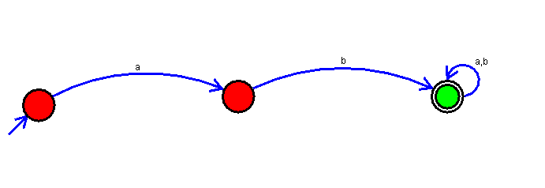

Result:

Successfully executed Deterministic Finite Automata for the language accepting strings ending with ‘abba’ over input alphabets ∑ = {a, b}.